BLANK LOAN REPORT QUERY DOCUMENT
- BANK LOAN REPORT | SUMMARY
KPI’S:
Total Loan Applications:
select count(id) as Total_Loan_Applications from Bank_Loan_data
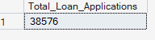
MTD Loan Applications:
select count(id) as MTD_Total_Loan_Applications from Bank_Loan_data
where MONTH(issue_date)=12 and year(issue_date)=2021
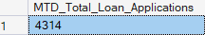
PMTD Loan Applications:
select count(id) as PMTD_Total_Loan_Applications from Bank_Loan_data
where MONTH(issue_date)=11 and year(issue_date)=2021
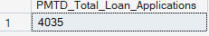
Total Funded Amount:
select sum(loan_amount) as Total_Funded_Amount from Bank_Loan_data
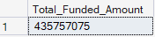
MTD Total Funded Amount:
select sum(loan_amount) as MTD_Total_Funded_Amount from Bank_Loan_data
where MONTH(issue_date)=12 and year(issue_date)=2021
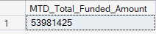
PMTD Total Funded Amount:
select sum(loan_amount) as PMTD_Total_Funded_Amount from Bank_Loan_data
where MONTH(issue_date)=11 and year(issue_date)=2021
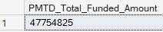
Total Amount Received:
select sum(total_payment) as Total_Amount_Received from Bank_Loan_data
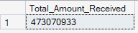
MTD Total Amount Received:
select sum(total_payment) as MTD_Total_Amount_Received from Bank_Loan_data
where MONTH(issue_date)=12 and year(issue_date)=2021
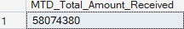
PMTD Total Amount Received:
select sum(total_payment) as PMTD_Total_Amount_Received from Bank_Loan_data
where MONTH(issue_date)=11 and year(issue_date)=2021
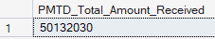
Average Interest Rate:
select round(avg(int_rate)*100,2) as Average_Interest_Rate from Bank_Loan_data
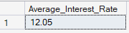
MTD Average Interest Rate:
select round(avg(int_rate)*100,2) as Average_Interest_Rate from Bank_Loan_data
where MONTH(issue_date)=12 and year(issue_date)=2021
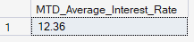
PMTD Average Interest Rate:
select round(avg(int_rate)*100,2) as Average_Interest_Rate from Bank_Loan_data
where MONTH(issue_date)=11 and year(issue_date)=2021
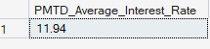

Average DTI:
select round(avg(dti)*100,2) as Avg_DTI from Bank_Loan_data
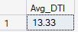
MTD Average DTI:
select round(avg(dti)*100,2) as Avg_DTI from Bank_Loan_data
where MONTH(issue_date)=12 and year(issue_date)=2021
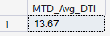
PMTD Average DTI:
select round(avg(dti)*100,2) as Avg_DTI from Bank_Loan_data
where MONTH(issue_date)=11 and year(issue_date)=2021
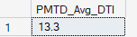
Good Loan Percentage:
select(count(case when loan_status='Fully Paid' or loan_status='Current' then id end)*100)/
count(id) as Good_loan_percentage from Bank_Loan_data
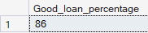
Good Loan Applications:
select count(id) as Good_loan_Applications from Bank_Loan_data
where loan_status='Fully Paid' or loan_status='Current'
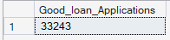
Good Loan Funded Amount:
select sum(loan_amount) as Good_loan_Funded_amount from Bank_Loan_data
where loan_status='Fully Paid' or loan_status='Current'
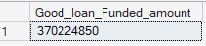

Good Loan Total Received:
select sum(total_payment) as Good_loan_Total_Received from Bank_Loan_data
where loan_status='Fully Paid' or loan_status='Current'
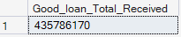
Bad Loan Percentage:
select(count(case when loan_status='Charged Off' then id end)*100)/
count(id) as Bad_loan_percentage from Bank_Loan_data
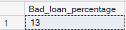
Bad Loan Applications:
select count(id) as Bad_loan_Applications from Bank_Loan_data
where loan_status='Charged Off'
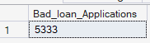
Bad Loan Funded Amount:
select sum(loan_amount) as Bad_loan_Funded_Amount from Bank_Loan_data
where loan_status='Charged Off'
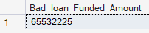
Bad Loan Total Received:
select sum(total_payment) as Bad_loan_Total_Received from Bank_Loan_data
where loan_status='Charged Off'
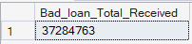

Loan Status:
select loan_status,
count(id) as [Total Loan Applications],
sum(loan_amount) as [Total Funded Amount],
sum(total_payment) as [Total Amount Received],
sum(case when MONTH(issue_date)=12 then loan_amount else 0 end) as [MTD Funded Amount],
sum(case when MONTH(issue_date)=12 then total_payment else 0 end) as [MTD Amount Received],
avg(int_rate)*100 as [Average Interest Rate],
avg(dti)*100 as [Avg DTI] from Bank_Loan_data
group by loan_status;

BLANK LOAN REPORT QUERY DOCUMENT
- BANK LOAN REPORT |OVERVIEW
KPI’S:
Monthly Trends by Issue Date:
select
month(issue_date) as Month_Number,
datename(month,issue_date) as Month_Name,
count(id) as Total_Loan_Applications,
sum(loan_amount) as Total_Funded_Amount,
sum(total_payment) as Total_Amount_Received
from Bank_Loan_data
group by month(issue_date),datename(month,issue_date)
order by month(issue_date)
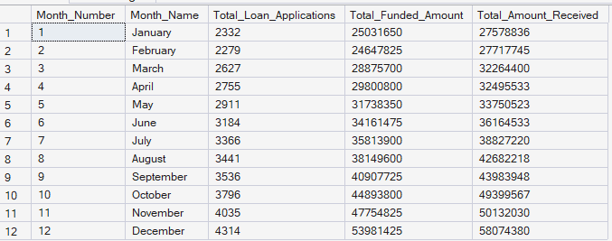
Regional Analysis by State:
select address_state,
count(id) as Total_Loan_Applications,
sum(loan_amount) as Total_Funded_Amount,
sum(total_payment) as Total_Amount_Received
from Bank_Loan_data
group by address_state
order by count(id) desc
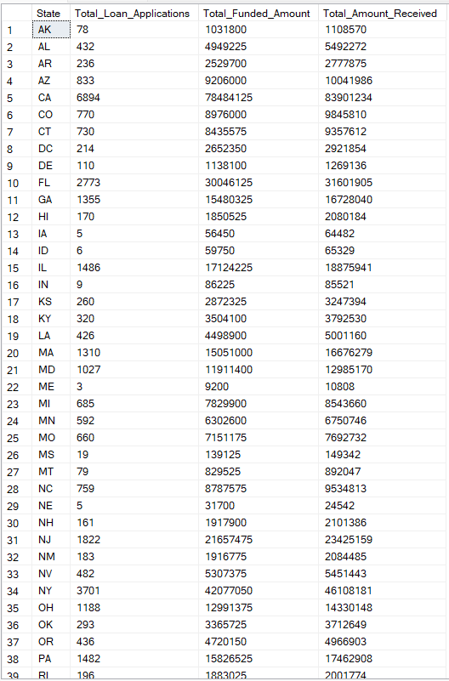
Loan Term Analysis:
select term,
count(id) as Total_Loan_Applications,
sum(loan_amount) as Total_Funded_Amount,
sum(total_payment) as Total_Amount_Received
from Bank_Loan_data
group by term
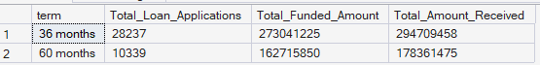
Employee Length Analysis:
select emp_length,
count(id) as Total_Loan_Applications,
sum(loan_amount) as Total_Funded_Amount,
sum(total_payment) as Total_Amount_Received
from Bank_Loan_data
group by emp_length
order by count(id) desc
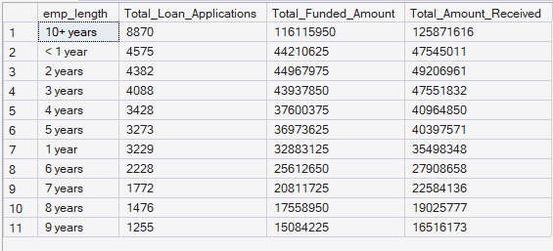

Loan Purpose Breakdown:
select purpose,
count(id) as Total_Loan_Applications,
sum(loan_amount) as Total_Funded_Amount,
sum(total_payment) as Total_Amount_Received
from Bank_Loan_data
group by purpose
order by count(id) desc
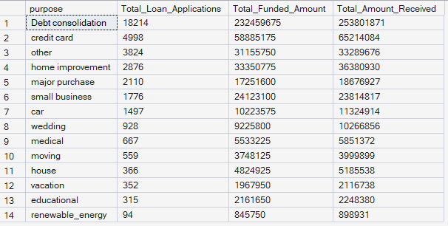
Home Ownership Analysis:
select home_ownership,
count(id) as Total_Loan_Applications,
sum(loan_amount) as Total_Funded_Amount,
sum(total_payment) as Total_Amount_Received
from Bank_Loan_data
group by home_ownership
order by count(id) desc
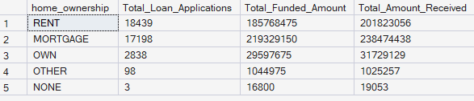
Home Ownership Analysis by Grade "A":
select home_ownership,
count(id) as Total_Loan_Applications,
sum(loan_amount) as Total_Funded_Amount,
sum(total_payment) as Total_Amount_Received
from Bank_Loan_data
where grade='A'
group by home_ownership
order by count(id) desc
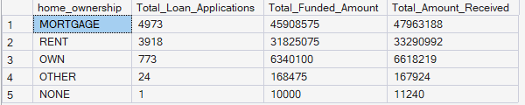
Home Ownership Analysis by Grade "A" and address_state is "CA":
select home_ownership,
count(id) as Total_Loan_Applications,
sum(loan_amount) as Total_Funded_Amount,
sum(total_payment) as Total_Amount_Received
from Bank_Loan_data
where grade='A' and address_state='CA'
group by home_ownership
order by count(id) desc;
